Model Parallelism Output:

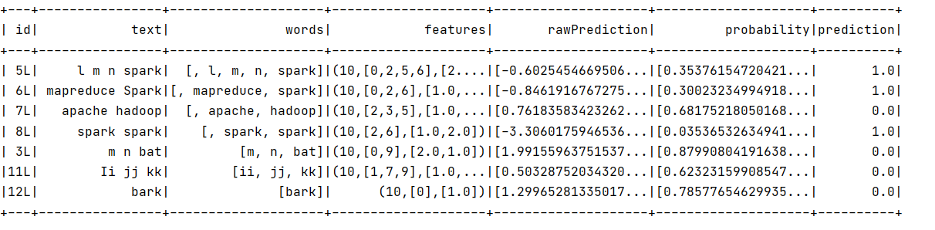

Data Parallelism Output:

